Trophies & Medals:

LOG General Trophy (Trophy Cup)
Item | Pair
LoG Winner (Winner + Runner-up Trophy cup pair) | 1

LoG Sports Trophy (Acrylic Trophies with base)
Item | Pair
Futsal Trophy (Winner + Runner up Pair) | 1
Volleyball Trophy (Winner + Runner up Pair) | 1
Basketball Trophy (Winner + Runner up Pair) | 1
Throwball Trophy (Winner + Runner up Pair) | 1
Cricket Trophy (Winner + Runner up Pair) | 1
Badminton Boys Trophy (Winner + Runner-up Pair) | 1
Badminton Girls Trophy (Winner + Runner-up Pair) | 1
TT Boys Trophy (Winner + Runner-up Pair) | 1
TT Girls Trophy (Winner + Runner-up Pair) | 1
 | Quantity
MVP of LoG Trophy (Winner Only) | 1
Valorant (Winner Only) | 1
CS2 (Winner Only) | 1
Chess (Winner Only) | 1
Snooker (Winner Only) | 1
Foosball (Winner Only) | 1

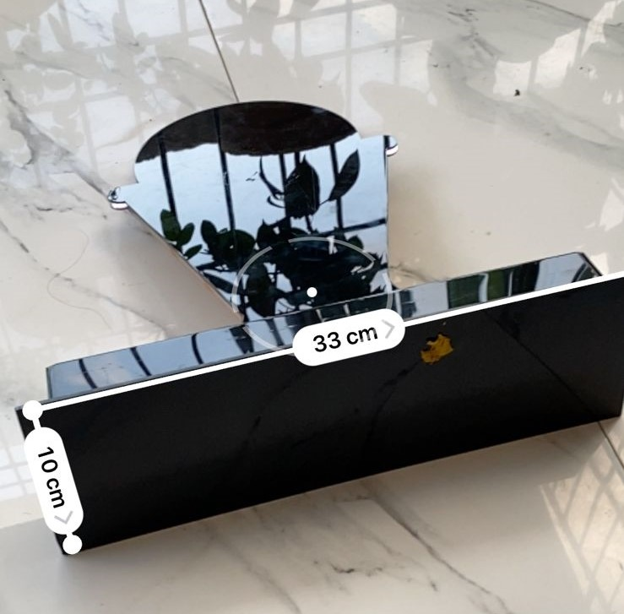
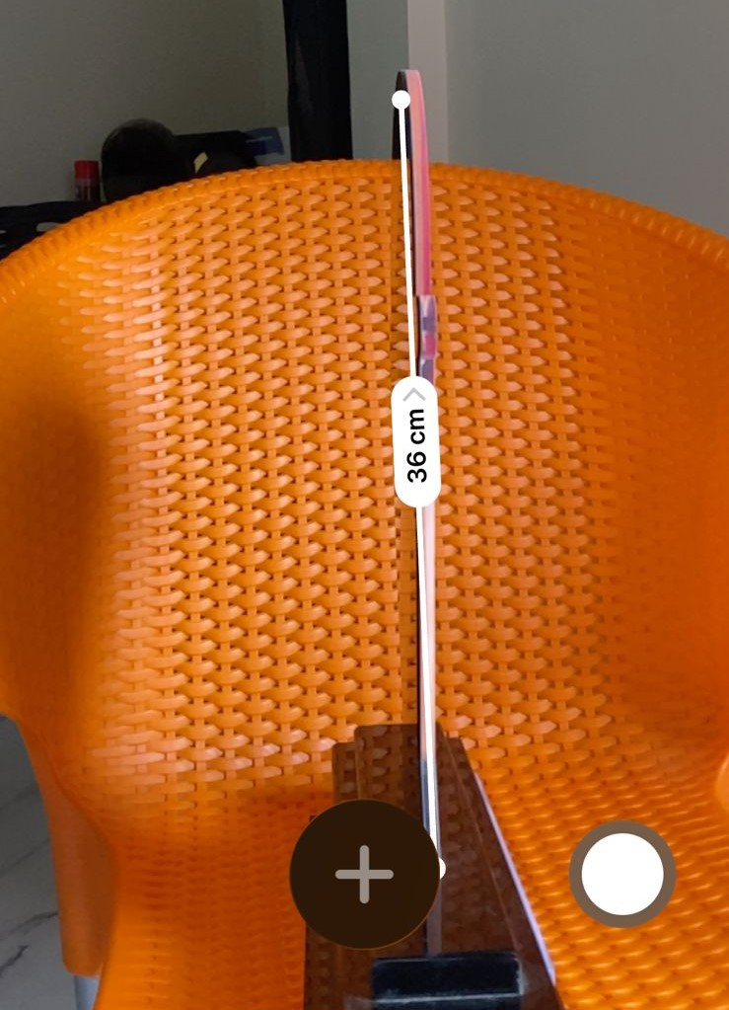
LOG Medals
Item | Quantity
LoG Medals (One side printing) | 200

Hoodies:

Hoodies
Item | Quantity
Hoodies (280 gsm, both normal hoodie  and drop shoulder hoodie) Front ,back Printing | 21

For Excom - 10
For Faculty - 3
For House and Co-House Captains - 8

